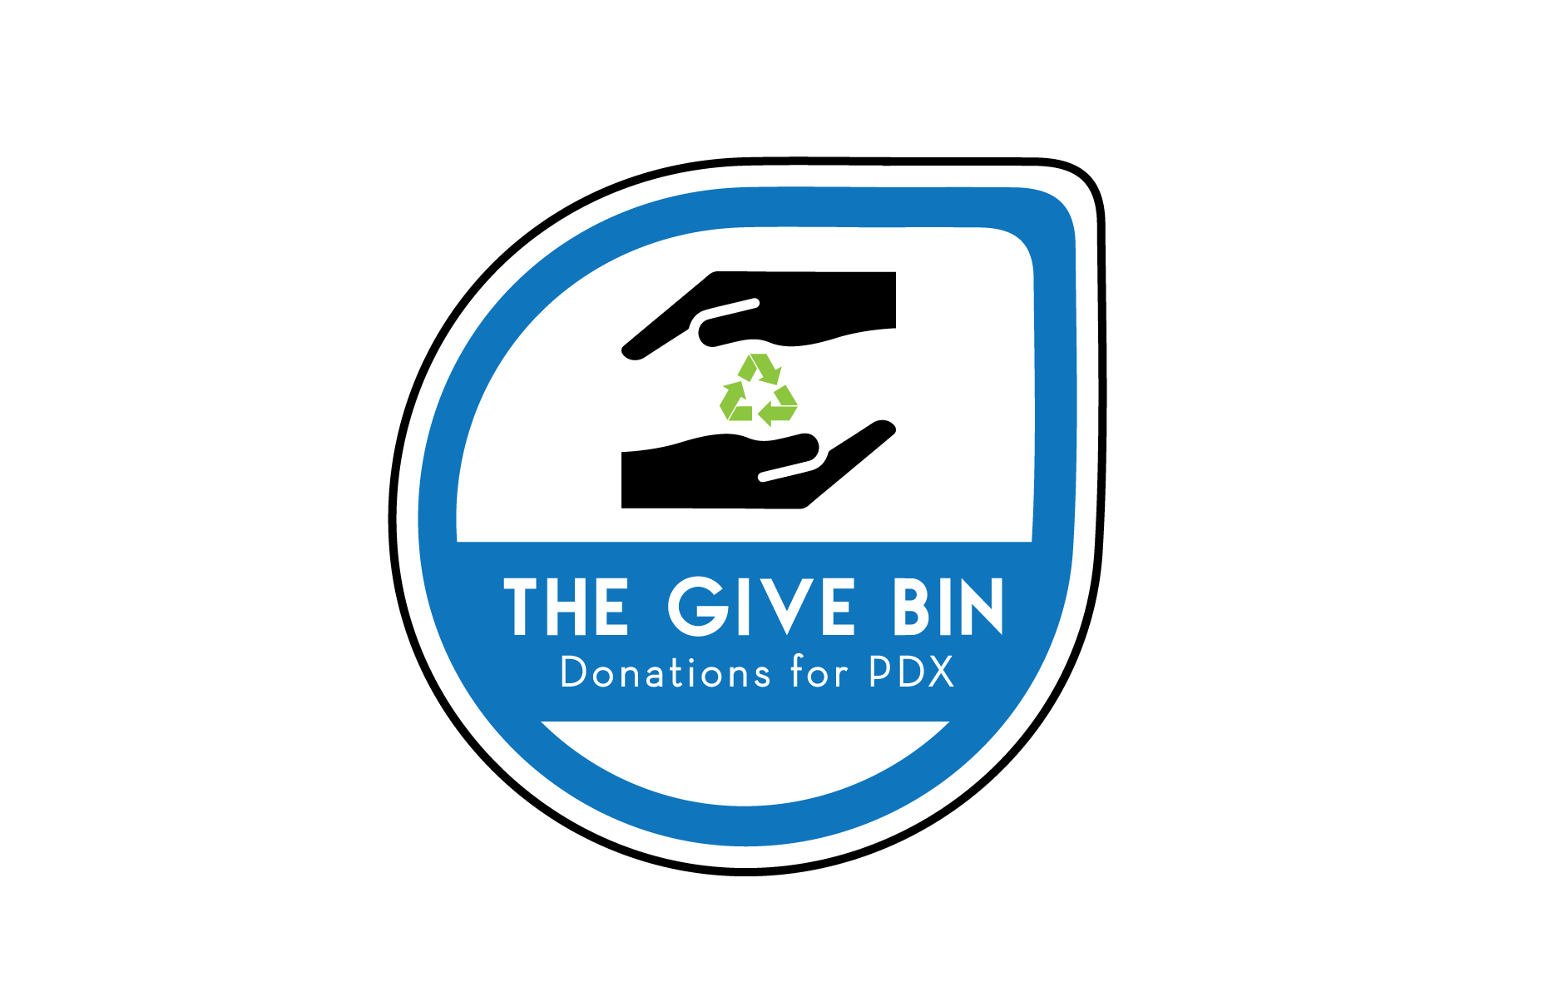

TABLE OF CONTENTS
Executive Summary 2
Overview 3
Breakdown of Services 5
Partnerships & Goods Collected 6
Organization & Oversight 8
BUDGET & Sustaining Oprations 9

Executive Summary

Objective: Our grant submission seeks to expand a pilot launched in 2020 to collect reusable goods from Metro Portland neighborhoods for the distribution and benefit of multiple local non-profits serving homeless, and other underserved communities. Our goal is to divert as many reusable goods from landfill as possible while simultaneously benefiting the overall Portland Metro area, by setting up collection locations that make the donation of reusable goods easier than alternative, existing options.

These goals are fully In line with Metro's 2030 Regional Waste Plan and meet the diversity, equity, and inclusion goals of the Investment and Innovation Grant.

Proven Operations: The Give Bin already has partnerships established multiple local non-profits, including Trash for Peace, the Transition Projects, Habitat for Humanity, the Arc of Multnomah, and Scrap. We leveraged these partnerships to operate a pilot in 2020 Including logistics, sorting, and drop-off. Our product categories thus far include apparel, basic housing needs, reusable bulky 'waste', and craft materials. Each biweekly run has the ability to collect up to 1500 pounds of diverted material.

This business plan lays out the approach for our pilot and our plan of action to expand from a single bin location and bulky waste collection point to six bin locations and a doubling of our collection event points. Beyond this expansion, the goal of The Give Bin is to continually expand the number of bins, collection events, and partner organizations, to continually be doing more good for the Metro area.

Information on The Give Bin can also be found online at TheGiveBin.com

Overview

Business Purpose

Our business seeks to launch and operate a pilot focused on the collection and distribution of reusable goods via a bin network, for the benefit of multiple non-profits within the Portland Metro area and to divert these same goods from the landfill.

The Problem

The current options for residents to divert reusable goods from the landfill are limited. People in our community currently have the option to either drive to donation centers like Goodwill’s 53 sites in the Willamette Valley (Oregon), or go directly to limited drop off locations and times for individual organizations.

Residents may also use online 1-to-1 approaches to divert reusable goods, such as Craigslist, Facebook, and Rooster. These methods don’t scale though, and may be good for a single or few items but don’t provide for the high volume of reusable goods making their way Into Metro's landfills.

Goods that are donated to Goodwill are marked up, and therefore inaccessible at scale to nonprofits. Other collection organizations, like Gaia In Portland or Gemtext in Washington, sell their collected goods to areas outside of their collection areas, Including overseas, and therefore don’t Inherently help the community.

In speaking with nonprofit organizations serving populations in need, they state universally that donations peak during the December holiday season, but then are Insufficient for much of the rest of the year. Insufficient donations can be a large problem for these organizations' constituents. Our business seeks to bridge this gap, to provide collection points 24/7 via our bins or via specific collection events.

Additionally, none of our partner organizations amongst themselves can afford a truck and the necessary manpower to handle the collection of the donations they seek. The Give Bin spreads these costs across multiple nonprofits that enables them all to scale their volume of donations and ensure donations are available throughout the year.

Our Solution

The Give Bin launched in 2020 to collect reusable goods from Metro Portland neighborhoods for the distribution and benefit of multiple local non-profits serving homeless, and other underserved communities, by setting up collection locations that make the donation of reusable goods easier than alternative, existing options.

Our operation isn't much more complex than simply two trained drivers and a truck, backed by a network of partnerships and fixed pickup locations. The fixed locations across the supply chain, rather than the unplanned ad hoc approach nonprofits' take today for donation collections, enable us to significantly reduce costs, and make collection more efficient.

Our bulky waste collection events focus on multi-unit housing residences, operated by Home Forward, such as Dekum Court In North Portland. These residences typically don’t have the resources, such as a car or funds, to properly dispose of bulky waste.

Our employment Is secured through Ground Score, a program operated by Trash for Peace, that offers low-barrier employment opportunities to homeless and housing-insecure Individuals.

Our approach is innovative, and there's no similar model that exists in the USA. It strengthens the Metro region’s system for reducing landfilled waste, and provides for a new reuse service and infrastructure via a simple approach. Our option provides a more convenient alternative, to establish bin locations within walking distance of people's residences. For bulky waste, like mattresses and couches, we offer collection events in neighborhoods, under the guidance of Trash for Peace's environmental promoters program. By operating with fixed locations and scheduled collection events, The Give Bin’s collection and distribution operations minimizes overall costs and complexity. The end result is a greater amount of reusable goods that are put back into a circular economy and less landfill space used.

By comparison, Gemtext is a Northwest-based collector of apparel only and via their roughly 100-200 bins located In four cities (Spokane, Portland, Boise, Coeur d'Alene) was able to collect 24,243,069 pounds of apparel from January 2011 through December 2018. The Give Bin, with bulky waste and a greater number of collected product categories, has the potential to collect much more on a per run basis.

The Win-Win-Win-Win of the Give Bin

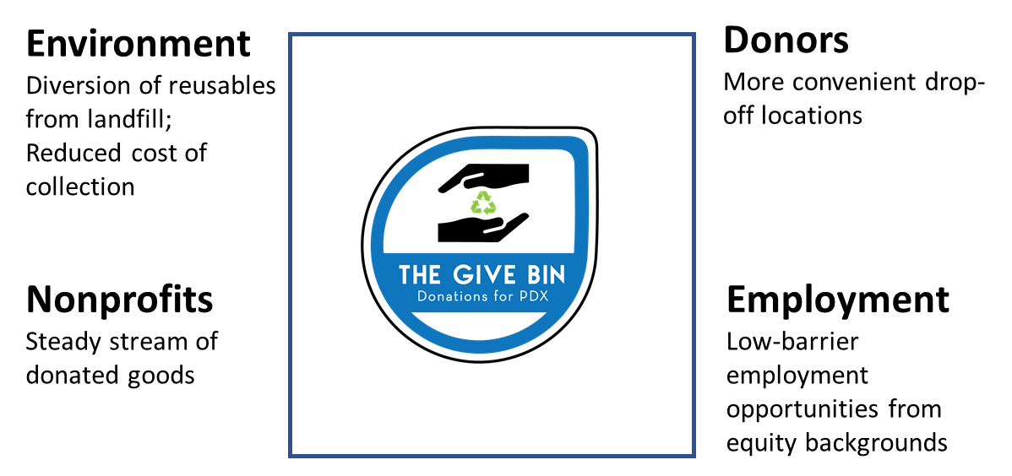

Breakdown of Services

The Give Bin involves logistics, drivers and sorters, and the necessary materials to execute the operation. Both collection events for bulky waste and the collection of reusable goods from the bin locations are executed by our staff every other week.

The bin locations and the collection event locations are fixed, known to our drivers prior to each run. This helps to reduce costs and ensure efficiencies. Each run Involves the following activities:

Collection: fixed locations, fixed days. Six bin locations. 2-3 bulky waste collection event locations, at multifamily housing properties.

For bulky waste events, the events will be held at locations with a covering (e.g. overhang, roof, or awning) to avoid any materials getting wet In the rain. Where a covering Is not available, Trash for Peace's environmental promoters will guide residents and donors to not bring their materials out until our drivers are present, and communicate time windows.

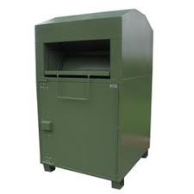
Sorting: completed at the time of collection (truck-side) and placed into bins within the truck. Based on our portfolio of nonprofit and recipient partenrs, we know beforehand the sorting categories

Data Collection: data collection includes weight and/or cubic volume of goods collected. Completed at a local service provider that Is currently being used by the Rebuilding Center on Mississippi Ave, Portland.

The Give Bin has already spoken with Rob Mason, the Senior Solid Waste Planner at Metro, and we will be submitting tallies to him on a regular basis, as well as fulfilling the data submission requirements of the Metro I&I grant. These data include:
- Pounds of bulky waste collected
- Pounds or cubic feet of other reusable materials collected, broken down by category

Drop-off: our recipient partners know ahead of time a day and time window for drop-off, so that they can staff appropriately and use their limited resources efficiently. They are able to take only the materials they need at that time. Where materials may be needed by more than one organization, we have the ability to modify the sequence of drop-off routes across runs to provide an equitable distribution of the goods collected.

Metro Transfer Station: each biweekly run ends at a Metro Transfer Station, to dispose of the goods that were unusable or unwanted by the recipient organizations. This step too Includes data collection.

The Give Bin has already spoken with Rob Mason, the Senior Solid Waste Planner at Metro, and we will be submitting tallies to him on a regular basis, as well as fulfilling the data submission requirements of the Metro I&I grant. These data include:
- Pounds of bulky waste donated vs. landfilled
- Pounds or cubic feet of other reusable materials donated vs. landfilled, broken down by category

Our services will exclude:
- Any ad hoc or unplanned pick-up or drop-off locations.
- Warehousing services for any goods. Each collection run ends at a Metro Transfer Station that same day.
- Cleaning of any material goods (same as Goodwill, and other for-sale donation organizations).

Partnerships & Goods Collected
The Give Bin already has a number of organizations signed up as recipient partners and donors-in-kind, across a breadth of product categories and services. Each additional product category enables each Give Bin and collection event to collect more reusable goods and increased levels of diversion. We hear from our partners that individually they can’t afford to set up the type of collective service that The Give Bin is establishing. For these organizations, the fixed and variable costs are spread across in such a way that the cost per organization is achievable (although The Give Bin is currently not seeking to cover its costs during the pilot and the duration of the Metro I&I grant).
Recipient No-Markup Organizations:
- Habitat for Humanity, NE Killingsworth St., Portland. Habitat for Humanity helps families build and improve places to call home. Bulky Waste recipient.
- Transition Projects, NW Hoyt, Portland. Each year, Transition Projects assists more than 10,000 people experiencing homelessness, including placing more than 1,000 people into affordable housing and then support them in retaining that housing. Apparel, winter clothing, sleeping bags, tents, unopened hygiene products, and towels recipient.
- Oregon E-cycles, State of Oregon. Oregon E-cycles ensures electronics are recycled in a way that protects human health and the environment. Electronics waste recipient, including items not wanted or needed by Free Geek or other organizations.
Recipient Organizations That Sell Donated Goods at a Markup:
- Reclaim It, N Killingsowrth St., Portland. Reclaim It is involved in the reuse, reclaim, and repair of used furniture. Bulky waste recipient.
- Scrap Creative Reuse, SW Alder St., Portland. Scrap’s mission is to inspire creative reuse and environmentally sustainable behavior by providing educational programs and affordable materials to the community. Crafts supplies recipient.
- The Arc of Multnomah County, NE Halsey St., Portland. The Arc of Multnomah County is a non-profit organization serving people with intellectual and developmental disabilities. Bulky waste, and apparel recipient.
- Free Geek, SE 10th Ave. Portland. Free Geek’s mission is to sustainably reuse technology, enable digital access, and provide education to create a community that empowers people to realize their potential. Electronics recipient, including computers, monitors, peripherals, and printers.
Service Organizations, Donations in Kind:
- RCSG Logistics Services, Portland. RCSG is a minority-owned and veteran-owned supply chain services company based in Portland. RCSG is donating the use of their logistics fleet of trucks for The Give Bin’s pilot and beyond the pilot until time TBD.
- Trash for Peace, North Portland: Trash for Peace’s vision is to empower healthy communities to live in a world without waste. Trash for Peace is the fiscal sponsor for The Give Bin and provides financial controls and oversight for the entire project, as well as insurance and overhead.
- Ground Score, North Portland: Ground Score is an association of environmental workers who create and fill low-barrier waste management jobs, prioritizing work opportunities for those facing work and housing insecurity. Ground Score is supplying employees for The Give Bin, including drivers/sorters and marketing teams to promote the The Give Bin collection events and bin dropoffs. Ground Score also provides the environmental promoters located at our multi-unit family housing.
- Pinnacle Steel Works, SE Milport Rd., Milwaukie. Pinnacle Steel works will be supporting any potential of eventual removal of donation bins, including trucking, transport, and environmentally-conscious resale of the steel.
Summary of Goods Collected and Distributed:
- Apparel
- Bulky waste, namely furniture, table and chairs, and couches and loveseats. No mattresses.
- Electronics, namely computers, monitors, peripherals, and printers. TVs TBD.
- Towels
- New hygiene products
- Craft materials.

Organization & Oversight
The Give Bin Is already set up with an organization to support Its growth from one bin and collection event site to six bins and 2-3 event sites.

Financial Oversight & Controls
The Give Bin is a program under the umbrella of Trash for Peace, a Portland-based 501(c)(3) nonprofit with a long track record of successfully running programs using Metro and other grant sources. Trash for Peace’s other programs include Ground Score, and its Environmental Promoters program.

Trash for Peace provides an existing, proven structure for financial controls, invoicing, insurance, contracts as needed, and overall board oversight.

Laura Kutner, Executive Director
See resume included in the grant application.

Adam Gittler, Program Lead, PSU adjunct professor of Sustainability
See resume included in the grant application.

Drivers/Sorters, Lead Trainer
The Drivers/Sorters are employed via Trash for Peace's Ground Score program, which exists to remove employment barriers for homeless and housing insecure communities. All drivers/sorters earn a minimum of $20/hour, and will receive an orientation and training for sorting materials to help develop their skills. One of the important examples of skills needed is understanding what items will be donations for partner organizations versus what will go to landfill. The sorting will be completed next to the drop off bins for space and logistical reasons.

Our current lead driver, for the pilot, is Rigel Hope, and Rigel will continue during the duration of the grant period as well. Rigel Hope was previously employed by The Rebuilding Center as a driver, sorter, and trainer. He Is our training lead for all current and future employees.

Michael Fawcett is our second driver during our pilot. Michael is…

See resumes included in the grant proposal.

Equipment:

- 16' Truck
- Commercially-available tote bins (acquired via reusables channels, such as Craigslist and Facebook's 'Buy Nothing Portland' page
- Security locks
- Donation bins - see included quote from Securr for five bins, including graphics and delivery from Fresno, CA. Each bin is 36"x76"x42", painted green with an anti-graffiti coat and will have The Give Bin logo on it, along with donation instructions/guidance. At 66% full, each bin collects roughly 65 cubic feet of goods.

BUDGET & Sustaining Oprations
See grant application for budget.
Following the six-month duration of the grant funds, The Give Bin will be seeking to fund its ongoing operations through the following possible mechanisms:
- Private funding
- Additional grants
- Multi-unit family housing fees paid to avoid the current approach to solely using expensive waste haulers to take away bulky waste
- Per-pound collection fees paid by for-profit businesses for new, additional product categories collected (e.g. Rebag.com for designer handbags)
- Possible use of Metro services
The goal of The Give Bin is to continually expand the number of bins, collection events, and partner organizations, to continually be doing more good for the Metro area, its communities, and the environment.

